Experiment no:2

Configuration of Network Devices using Packet Tracer (Hub, Switch, Ethernet, Broadcast)

### 

### AIM:

To establish a Local Area Network (LAN) using Cisco Packet Tracer.

### 

### REQUIREMENTS:

End device - They are the devices through which we can pass message from one device to another and they are interconnected.

1. Switch/Hub - Interface Between two devices.
2. Cable - Used to connect two devices.

Procedure:

**STEP** 1: Click on end devices, select generic Pc’s drag and drop it on the window. Click on SWITCH drag and drop it on the window.

**STEP** 2: Select the straight through cable and connect all end device to switch. Assign

the IP address for all end devices. (Double click the end device Select →

 desktop → IP configuration static)

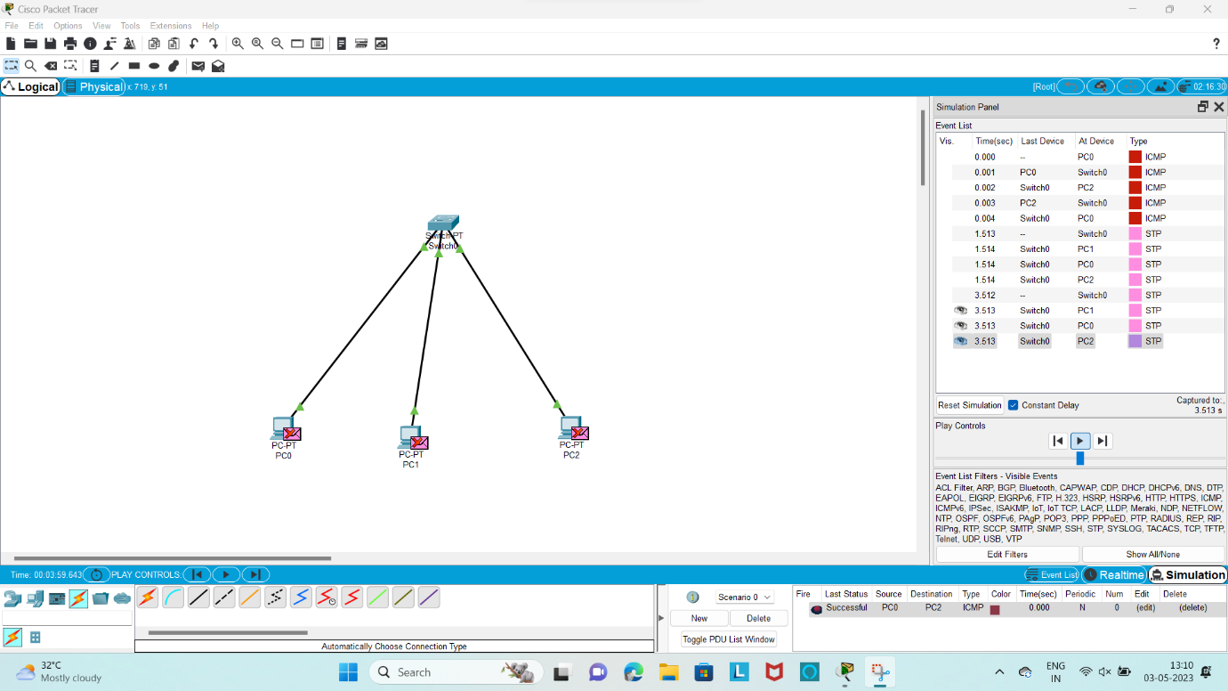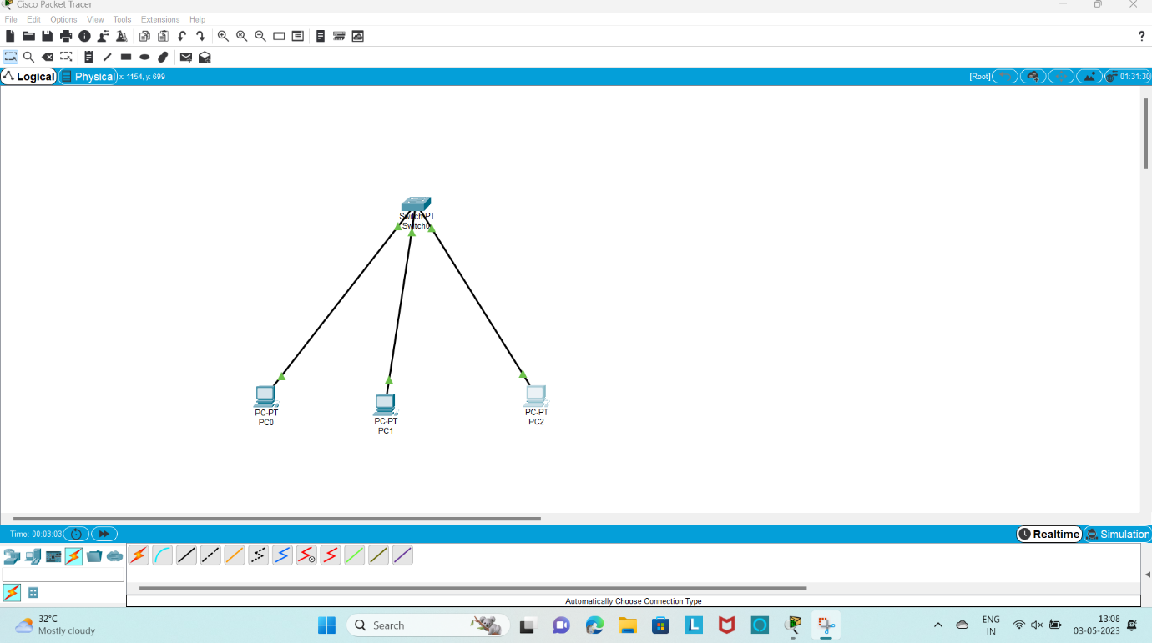

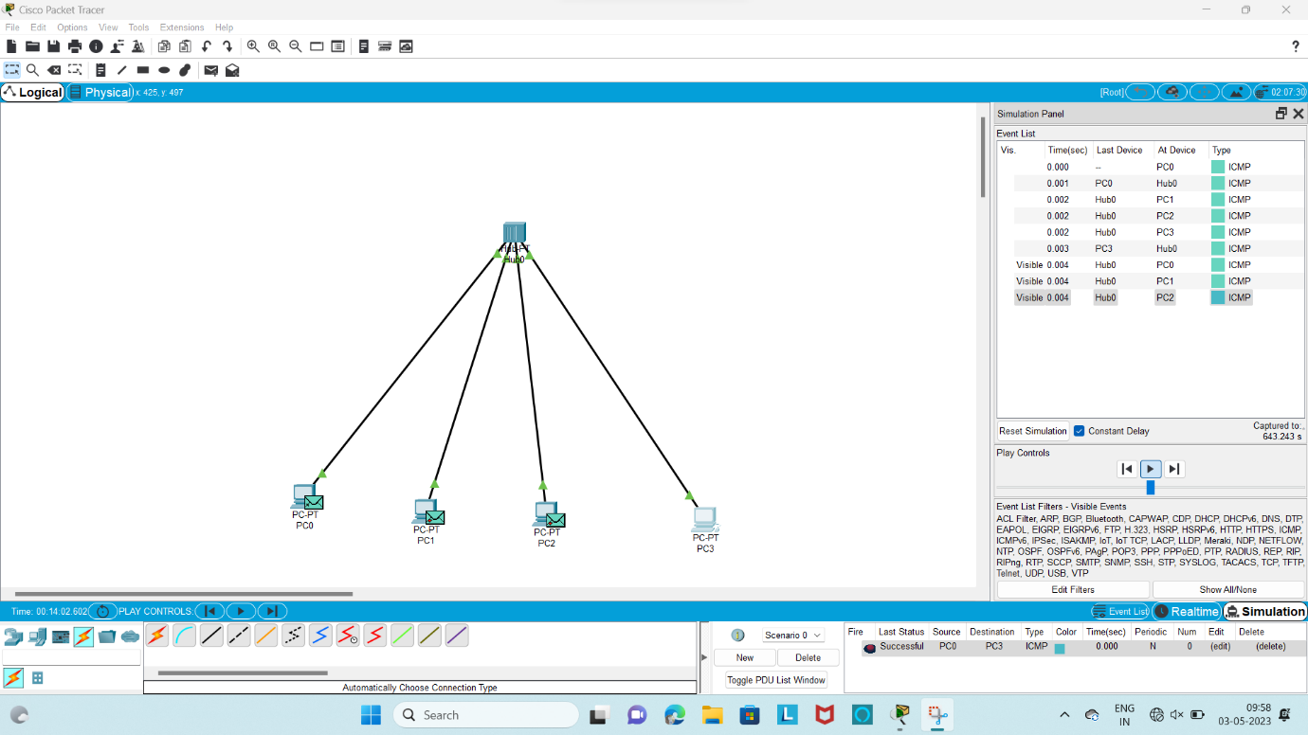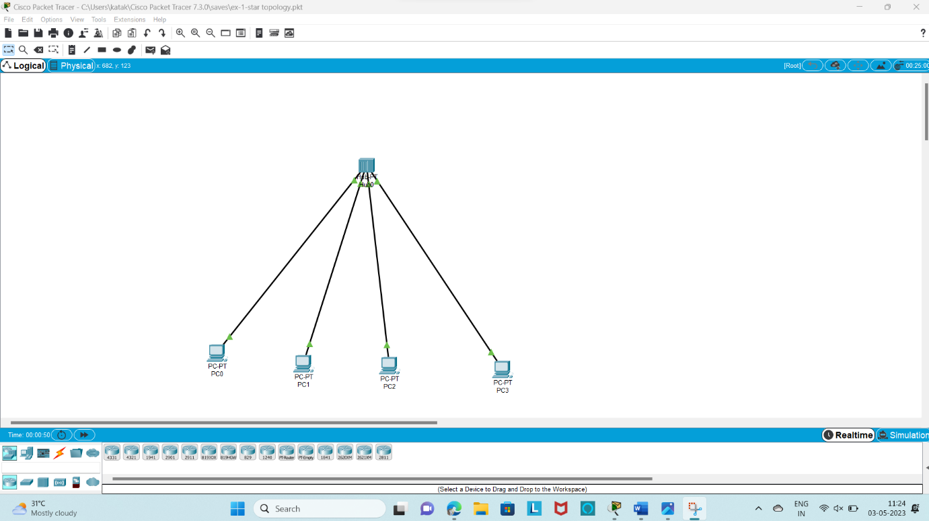

Result;

Configuration of networks devices using packet hub,switch,end systems is verified successfully